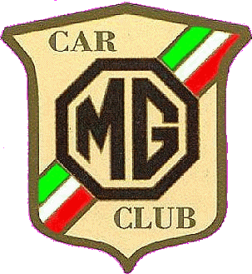 | MG CAR CLUB d' Italia  Registro italiano MG | Federato
 | MG CAR CLUB d' Italia  Registro italiano MG | 

VIIth MG BY THE SEA
19 - 25 May 2008
Gabicce Mare (Pesaro-Urbino)

We have pleasure in announcing the VII edition of MG BY THE SEA which will take place at Gabicce Mare as usual.
One more time this small and exclusive sea resort, now famous within the international MG family, will host this event being ready to greet its participants with its warm welcome. The special formula of the event is to offer a holiday in a pleasant area where participants can enjoy their MGs by following the many daily activities or simply go to the beach, being free not to participate in the outings and spending a relaxing week.
Gabicce Mare is just where the Adriatic coastline becomes hilly. The area around it is full of history, Roman ruins, medieval castles, art treasures and beautiful countryside.
This time we will visit the recently excavated Roman ruins in Rimini, an aviation museum, Ravenna and its mosaics, the old town of Fano and much more. We will also enjoy musical evenings; tasting of local wines and gastronomic products; competitions in ability tests and gymkhana; driving along the mythical Mille Miglia route and great bendy roads. Although this is the VII edition of MG BY THE SEA, we always show you something different - new routes, new thrills. We also wanted to offer a stop-over in Merano, South Tyrol, but an international conference caused recent cancellation of our booking. We are now investigating in Bolzano and will let you know later on about our findings. Our apologies for that.
We hope all European MG Car Clubs will be represented.

The number of foreign participants is limited to 130 cars.

Please fill in the attached forms and send them back as soon as possible to:

MG BY THE SEA c/o Associazione Albergatori,
Viale della Vittoria 49, 61011 Gabicce Mare (PU),Italy.
E-mail: mgbythesea@gabiccemare.com
Web: gabiccemareturismo.com
tel.+39.0541.953600, fax +39.0541.834517

Those who have not participated on previous occasions will be pleasantly surprised as we will all spend a great holiday amongst friends. Never forget the motto of the Italian MGCC : “MG is…to live freely, together!”. We look forward to seeing you there.

Fabio Filippello
President

Via Accademia dei Virtuosi, 22 – 00147 Roma - Italy
Tel.+39.333.2666939 Fax+39.06.5940557
E-mail: mgcarclub@mclink.it Web: mgcarclub.it

